|  |  |  |
| --- | --- | --- |
|  |  |  |

**Exp No:** 11 **Date:** 19/10/2020

**Name:** Swetha Saseendran

**Reg No:** 185001183

DISPLAY SYSTEM DATE AND TIME

## Aim:

To write assembly language programs to perform the following system operations:

1. Display System Date
2. Display System Time

# Programs:

### (i) SYSTEM DATE

## Algorithm:

* Declare the data segment.
* Initialize data segment with variables to store day, month and year.
* Close the data segment.
* Declare the code segment.
* Set a preferred offset (preferably 100h)
* Load the data segment content into AX register.
* Transfer the contents of AX register to DS register.
* Load 2Ah to AH register. (DOS function to obtain system date)
* Call interrupt 21h to service the DOS function.
* Load the offset address of variable ‘day’ to SI.
* Transfer contents of DL register through SI to variable ‘day’.
* Load the offset address of variable ‘month’ to SI.
* Transfer contents of DH register through SI to variable ‘month’.
* Load the offset address of variable ‘year’ to SI.
* Transfer contents of CX register through SI to variable ‘year’.
* Introduce an interrupt for safe exit. (INT 21h)
* Close the code segment.

|  |  |
| --- | --- |
| **PROGRAM** | **COMMENTS** |
| **assume** cs:code, ds:data | Declare code and data segment. |
|  |  |
| **data segment** | Initialize data segment with values. |
| day db 01 dup(?) | Variable to store day. |
| month db 01 dup(?) | Variable to store month. |
| year db 02 dup(?) | Variable to store year. |
| **data ends** |  |
|  |  |
| **code segment** | Start the code segment. |
| org 0100h | Initialize an offset address. |
| **start:** mov ax, data | Transfer data from “data” to AX. |
| mov ds, ax | Transfer data from memory location AX to DS. |
|  |  |
| mov ah, 2Ah | Load 2Ah to AH (DOS code for system date function) |
| int 21h | Interrupt DOS with 21h to get the system date. |
| mov si, offset day | Load offset of variable ‘day’ to SI. |
| mov [si], dl | Copy to ‘day’ the value of DL through SI. |
| mov si, offset month | Load offset of variable ‘month’ to SI. |
| mov [si], dh | Copy to ‘month’ the value of DH through SI. |
| mov si, offset year | Load offset of variable ‘year’ to SI. |
| mov [si], cx | Copy to ‘year’ the value of CX through SI. |
|  |  |
| mov ah, 4ch | Moves the hexadecimal value 4c to ah. |
| int 21h | When Software interrupt 21 is called with AH=4C, then current process terminates. (i.e., These two instructions are used for the termination of the process). |
| **code ends** |  |
| **end start** |  |

## Unassembled Code:

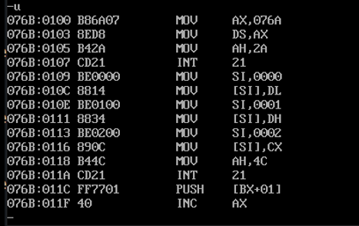

## Snapshot of sample input and output:

**INPUT:**

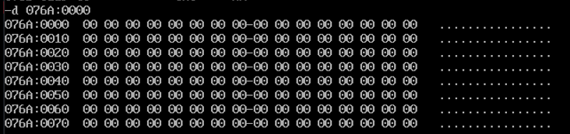

**OUTPUT:**

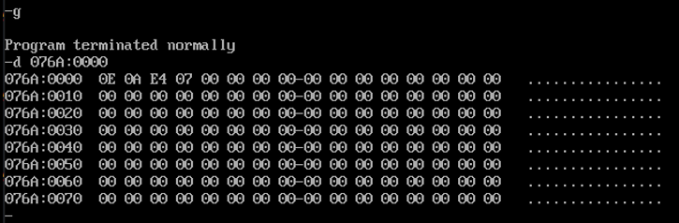

# (ii) SYSTEM TIME

## Algorithm:

* Declare the data segment.
* Initialize data segment with variables to store hour, minute and second.
* Close the data segment.
* Declare the code segment.
* Set a preferred offset (preferably 100h)
* Load the data segment content into AX register.
* Transfer the contents of AX register to DS register.
* Load 2Ch to AH register. (DOS function to obtain system time)
* Call interrupt 21h to service the DOS function.
* Load the offset address of variable ‘hour’ to SI.
* Transfer contents of CH register through SI to variable ‘hour’.
* Load the offset address of variable ‘minute’ to SI.
* Transfer contents of CL register through SI to variable ‘minute’.
* Load the offset address of variable ‘second’ to SI.
* Transfer contents of DH register through SI to variable ‘second’.
* Introduce an interrupt for safe exit. (INT 21h)
* Close the code segment.

|  |  |
| --- | --- |
| **PROGRAM** | **COMMENTS** |
| **assume** cs:code, ds:data | Declare code and data segment. |
|  |  |
| **data segment** | Initialize data segment with values. |
| hour db 01 dup(?) | Variable to store hour. |
| minute db 01 dup(?) | Variable to store minute. |
| second db 02 dup(?) | Variable to store second. |
| **data ends** |  |
|  |  |
| **code segment** | Start the code segment. |
| org 0100h | Initialize an offset address. |
| **start:** mov ax, data | Transfer data from “data” to AX. |
| mov ds, ax | Transfer data from memory location AX to DS. |
|  |  |
| mov ah, 2Ch | Load 2Ch to AH (DOS code for system time function) |
| int 21h | Interrupt DOS with 21h to get the system time. |
| mov si, offset hour | Load offset of variable ‘hour’ to SI. |
| mov [si], ch | Copy to ‘hour’ the value of CH through SI. |
| mov si, offset minute | Load offset of variable ‘minute’ to SI. |
| mov [si], cl | Copy to ‘minute’ the value of CL through SI. |
| mov si, offset second | Load offset of variable ‘second’ to SI. |
| mov [si], dh | Copy to ‘second’ the value of DH through SI. |
|  |  |
| mov ah, 4ch | Moves the hexadecimal value 4c to ah. |
| int 21h | When Software interrupt 21 is called with AH=4C, then current process terminates. (i.e., These two instructions are used for the termination of the process). |
| **code ends** |  |
| **end start** |  |

## Unassembled Code:

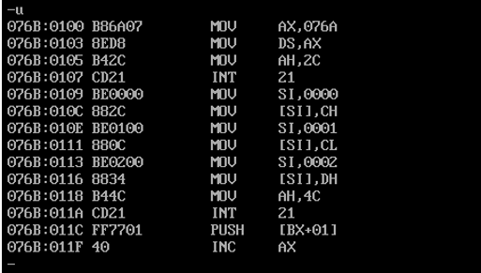

## Snapshot of sample input and output:

**INPUT:**

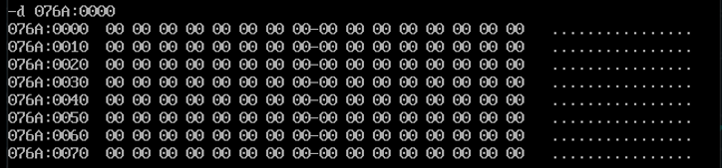

**OUTPUT:**

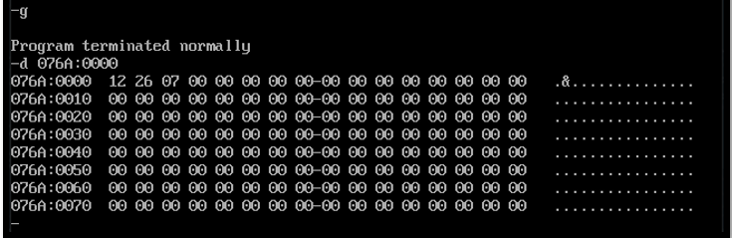

# Result:

The assembly level programs were written to perform the above specified system operations, namely, system date and system time and the output was verified.